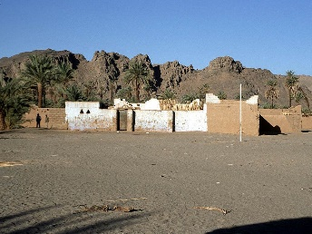
Bardai Brief
Prayer Points for
Mark & Andrea Hotchkin
MARCH 2017
Dear All
Here is our latest prayer note from Bardai.
Today we can see the mountains and the sky is blue which is true of most days but yesterday they were invisible behind a cloud of sandy dust. Temperatures are rising and we now only go down to 10⁰C outside at night and have been up to 35⁰C during the day.
We are settling into Bardai now and have stopped getting lost when we go out. It’s only small but the problem seems to be the streets are not straight so directions can be hard to work out. We are adapting to buying fruit off the back of pick-ups when they arrive in town and together with the dried meat and veg we brought our diet is good. We are grateful for those who make the 12 hour journey and bring the fruit from southern Libya. A trip to the local shops for Andrea usually involves a sit down, glass of tea and a 3 word chat in Teda.
After much thought about when we should start work at the hospital, this week we did our first day of consultations and we will do that once a week with patients being asked to see a Chadian doctor first. Another afternoon will be spent continuing to sort through all the equipment they have which is in piles of boxes in various cupboards and rooms. The operating block is now organised and we did a small operation there a week ago - it went well but the husband arrived from Ndjamena and took her to Libya 2 days later. The hospital now has 6 nurses, 2 doctors, a midwife and one aid midwife. There are enough staff to make it function well. Pray for the Director (administrator) and the Head doctor Abdel Karim who are very keen for this and also for the other staff who have shown varying degrees of enthusiasm. There is still much to be done to make the hospital work well and we all need to work together. We were taken to see the Governor and Prefect by the director and good contact was made. There are plans to meet with the local chiefs and mayor to encourage the population to come to the hospital as the story above tells there is a certain reticence and lack of confidence in the hospital.
Teda language learning continues with some progress. We can now make little sentences like ‘Today market tomatoes I to buy I went.’ That’s normal construction for Teda so takes a bit of getting used to. Together with the tonal pronunciation we have a lot of laughs in our lesson. It’s the same word for want and don’t want just a different tone!! I guess most people at market won’t expect you to ask if they have something and then say I don’t want it. Pray we may make progress and be happy to make mistakes and open our mouths. Pray also that we will not find hospital work taking over.
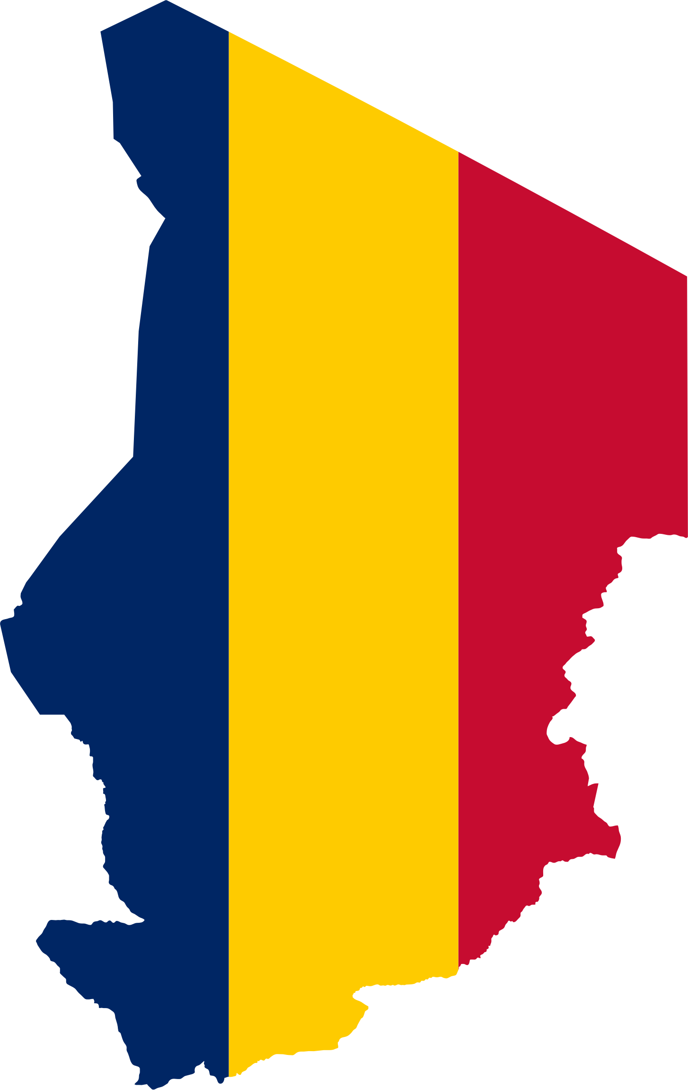
We went to see a house this week that we will now be renting once the couple who live in our house return in June. It is much nearer the hospital on a hill with a lovely view and is local stone built with a mud roof. We will be next to Oji’s sister as she owns the house and lives in an adjoining compound (Oji is Mark Ortman our team leaders- Teda co-worker). It is exciting to have found such a suitable place so easily and we praise God and pray that the improvements needed including a latrine will be easily made. Oji has gone to Libya to buy roofing material and wood for this.
We have been less at the language centre this week due to the Governor visiting the hospital and the Director asking us to be there. Until then Andrea had been helping Sheryl with her TEDA writing language classes for the primary children and also colouring and puzzle sessions. Mark had also helped a few children to read. Pray for the centre and all the cultural and language work that goes on there with Mark, Ulrika, Issaka and Sheryl.
Church here has been fun to go to. The service is just 2 hours so is short for Chad. The Minister is Pastor Issaka who heads up the cultural centre too and is here as a missionary to the Teda. There are around 60-70 adults from different denominations and parts of Chad with a lively but small choir and the sermon translated into Arabic. Pray for them as it is not an easy place for them, away from family and friends in the South.
Other events have included visits to peoples’ houses, a football match for the new governor to watch, Womens’ Day celebrations and some lovely walks on Sundays. All part of getting to know the area.
We are adapting to using the phone for email and communication in general is good. Ruth is well and busy at University. Rebecca has returned to Chad and is in Abeche working with a missionary doctor seeing psychiatric patients for a month. She is excited to have been offered a place at Bristol to study medicine and is waiting to see if she has any other offers.
Thanks as always for your prayers and support
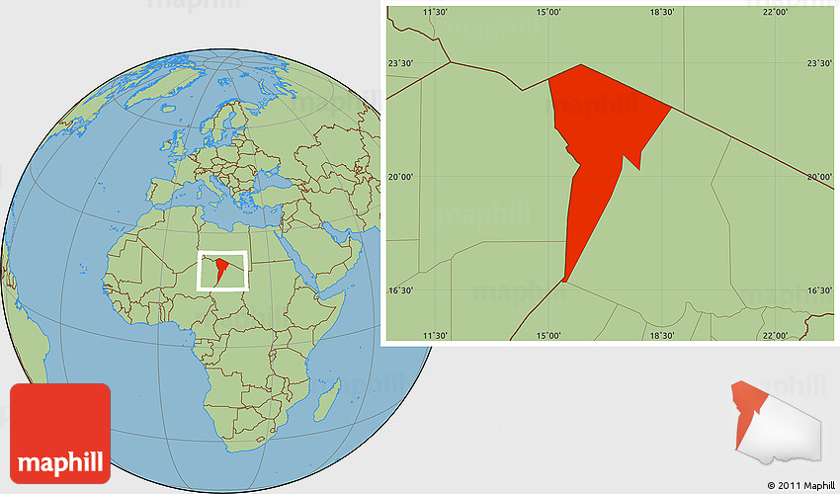
Mark and Andrea Hotchkin
PRAYER FOR:
- The Director (Administrator) and head Doctor Abdul Karim
- The language learning
- The hospital work not taking over
- Improvements to their new rented house to be easily achieved
- The Centre and all the cultural and language work that goes on
- The Church Pastor, being away from family and friends
- Communications / e-mail all by phone
- Ruth at Exeter University
- Rebecca currently in Chad for a further month, but waiting to hear back from Universities regarding places for studying medicine

