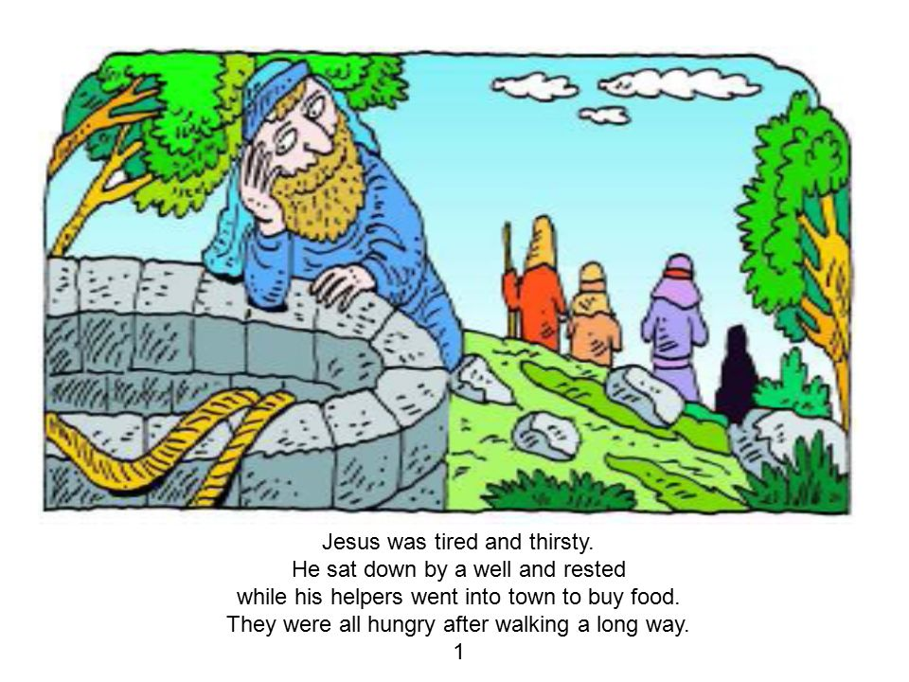  This was one of the stories Tim highlighted in his sermon. The fact that Jesus came to the well and rested for quite a while (whilst the disciples went to town for food).  We all lead busy lives, but we have to be careful to give time to rest our bodies, minds and souls. Time for prayer and listening to God is really important, as is time to read His word. |  | Personally I particularly like Mark Chapter 6, verse 31:-  Then, because so many people were coming and going that they did not even have a chance to eat, he said to them, “Come with me by yourselves to a quiet place and get some rest.”  I am sure you can all relate to that feeling of so much ‘coming and going’ and ‘no time to eat’ OR that phrase ‘I don’t know if I’m coming or going’. Jesus recommends finding a quiet place by yourself, or with Jesus, to get some rest.  It is also easy to feel guilty for doing nothing. But as it is a commandment and a recommendation of Jesus we should not feel guilty. Without quiet time it is difficult for God to speak to us and guide us as to what we should be doing. Maybe some of the ‘stuff’ we do that keeps us so busy is not God’s will, not what He wants us to do. We need to be able to discern God’s will for our lives and our activities – and this can only be achieved by giving time to God, and time to listen to him.  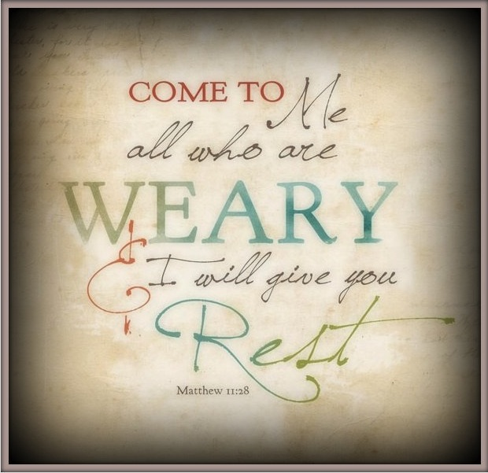

As they say at the end of the news …..  and finally….. Hebrews 4: 9-11 tells us:-  There remains, then, a Sabbath-rest for the people of God; for anyone who enters God’s rest also rests from their works, just as God did from his. Let us therefore make every effort to enter that rest, so that no one will perish by following their example of disobedience.  Perhaps we could use this summer to have a clear out of the ‘stuff’ that fills our time and removes our chance to rest. We could look at all the activities we do and decide what is pleasing to God and beneficial to us.  Have a lovely summer everyone! |  | Wakefield Baptist Church  Helping people follow jesus  Friday 31st March 2017  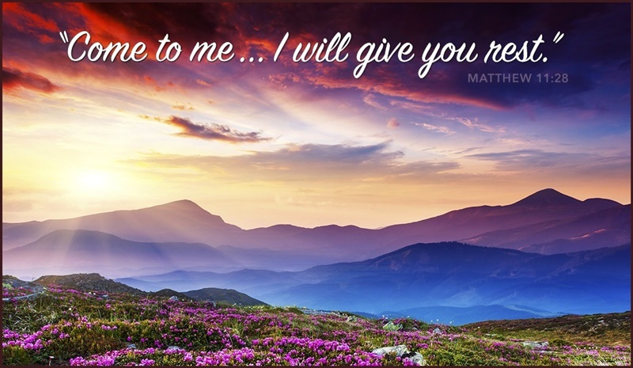  Following Tim Flatman’s sermon on Sunday I thought it would be good to continue the theme of ‘rest’, especially as the summer approaches and we think about holidays and ‘staycations’.  Tim explained that to rest is both a commandment and a well used practice by Jesus, our ultimate role model. Obviously, keeping a day free each week (the Sabbath perhaps, or another day if Sunday is busy for you) is a commandment in Genesis Chapter 2: 2-3. There are also numerous references to rest as good practice in the new testament, not least led by Jesus.

